Implicit Intent – WebLinkAndPhoneCallApp

**Learning Objective**: the goal of the assignment is to apply implicit intent concepts and invoke web link & phone calls.

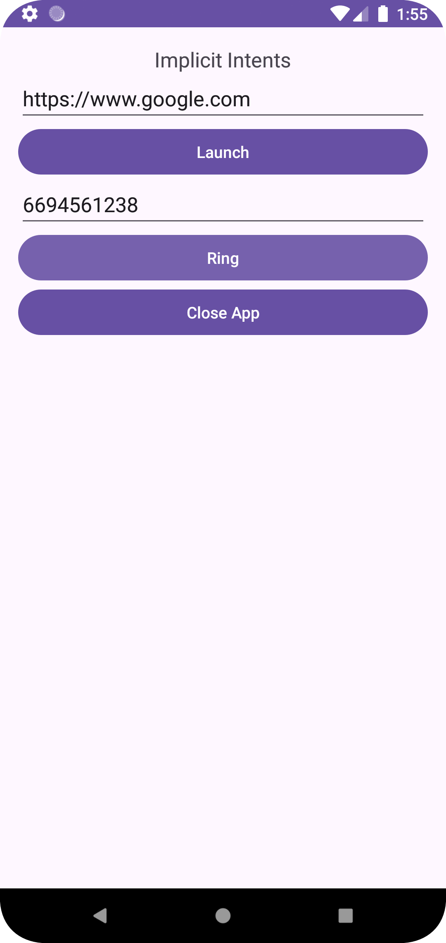

Tap the Lunch button on screen. It will take to the desired link. For example, google.com.



To call someone tap on the ring button. It will open the dialler and from there just make a call.

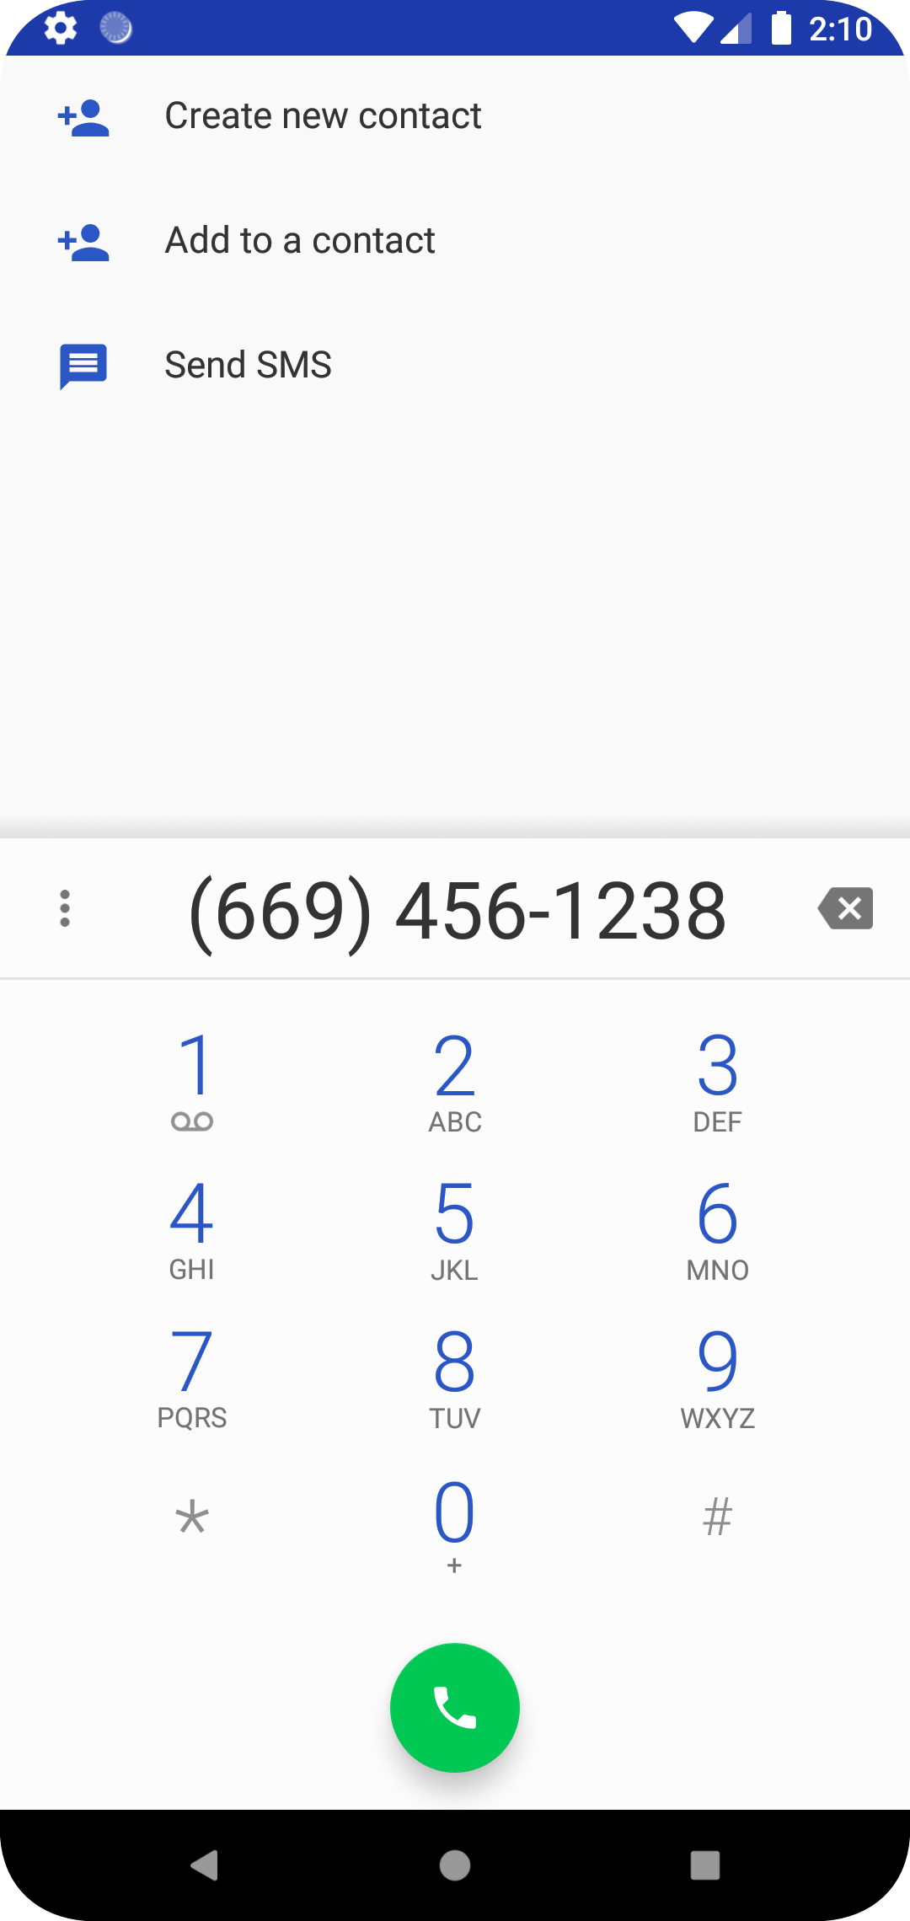

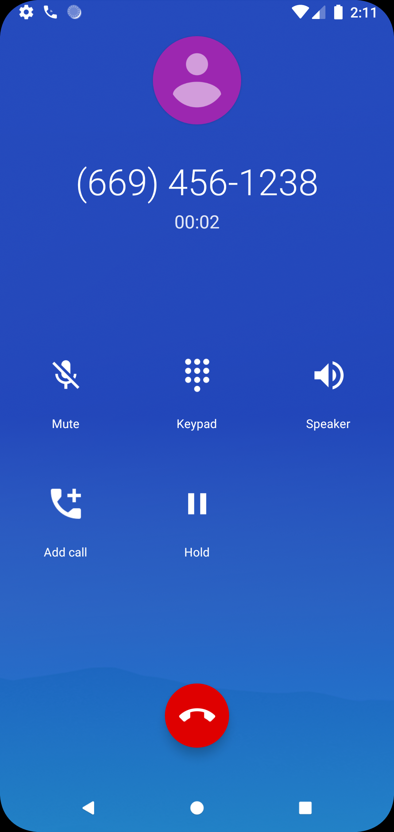

And lastly when clicked on Close App the application gets closed and every information is deleted.

Source code on GitHub: <https://github.com/RavirajWadnerkar/AndroidImplicitIntent>

Thank you 😊